SOFTWARE REQUIREMENTS SPECIFICATION

IEEE 830 / ISO·IEC·IEEE 29148 Format

Addressing Typographic Hallucination in Generative AI Images: An Open-Set Metric Learning Approach to Font Style Recognition
Version 1.1 · July 26, 2026

By
Janritch Diputado
Matt Cabarrubias

Christine D. Bandalan, MEng
Faculty Adviser

Revision History
Date | Version | Description | Author
2026-07-16 | 1.0 | Initial thesis-scoped SRS | Research team
2026-07-26 | 1.1 | Restructured to the IEEE 830 capstone template; adviser format revisions | Research team

1. Introduction

1.1 Purpose
This Software Requirements Specification (SRS) defines the functional and non-functional requirements for FontID version 1.x, the web demonstrator that exposes the thesis’s font-recognition model to a user. It is the artifact half of the study’s build method (Ch4 §4.10): a single-page application that accepts a generative-AI image, runs the open-set metric-learning pipeline, and returns a ranked shortlist of the closest Google Fonts for each detected line of text — or rejects the text as out-of-palette. The software will not perform font vectorization, licensing, or any commercial identification.

1.2 Document Conventions
Each requirement is labeled REQ-<section>-<n> (e.g., REQ-4.1-2) with priority High / Med / Low. Mandatory behavior uses shall; desired behavior uses should. Tables and figures follow APA 7th edition formatting.

1.3 Intended Audience and Reading Suggestions
The document is intended for the two researcher-developers, the faculty adviser, and the panel evaluating the demonstrator. The panel and adviser may read Section 2 for a high-level view of scope and functions; the developers should read Sections 3–5 in full; evaluators verifying the demo should focus on Section 4 (features) and Section 5 (non-functional requirements) to derive test cases.

1.4 Product Scope
FontID is a local demonstration harness, not a production service. It wraps the trained model so that hallucinated text crops map to a localized palette of the top 50–100 Google Fonts for free template reconstruction. Explicitly out of scope: user accounts, multi-user scaling, persistent storage, payment/licensing, and font vectorization. The app is single-page with three zones — Input → Processing → Results — and runs on one machine for the defense demo.

1.5 References
Ref# | Document Title | Version/Date | Source
[1] | Thesis Chapter 4 — Methodology (conceptual framework §4.4, architecture §4.5, build method §4.10) | 2026 | This thesis
[2] | IEEE Std 830-1998, Recommended Practice for Software Requirements Specifications | 1998 | IEEE
[3] | ISO/IEC/IEEE 29148:2018, Requirements engineering | 2018 | ISO/IEC/IEEE
[4] | Google Fonts open-source font library | current | https://fonts.google.com

2. Overall Description

2.1 Product Perspective
FontID is a new, self-contained front end over an existing trained model; it adds no new learning logic. The runtime path is layered — React client → FastAPI backend → PyTorch inference service → model weights and font assets — as detailed in the system-architecture diagram (Ch4 §4.5.2, Fig 9). The trained metric head is produced offline; the app only loads and serves it.

2.2 Product Functions
- Accept a GenAI image by drag-drop, file browse, or a bundled sample — drawn from a pool of at least 10 real AI-generated demo images, never part of any training data, with 3 offered at random each start-up.
- Localize the text region(s) in the image and crop each one.
- Embed each crop and rank it against the font palette.
- Return a Top-K shortlist per crop with a similarity score, or reject it as out-of-palette.
- Render each candidate font as a live preview of the detected text for visual confirmation.

2.3 User Classes and Characteristics
User class | Characteristics | Privileges/Access
Designer / end user | Non-technical; wants a free font match to rebuild a template. | Standard access: uploads an image, reads the Top-K shortlist.
Researcher / evaluator | The team + panel; technical. | Full local access: drives the demo, inspects backend score/τ logs, confirms open-set reject behavior.

2.4 Operating Environment
- Client: current Chrome / Firefox / Edge (latest two versions), desktop viewport.
- Server: Python 3.11+, FastAPI, PyTorch, packaged with Docker; runs on the presenter’s laptop (localhost). GPU optional — CPU inference acceptable for single-image demo latency.
- Assets: DINOv2 + baseline weights from HuggingFace Hub; Google Fonts files for palette matching and preview rendering.

2.5 Design and Implementation Constraints
- Stack is fixed by the methodology (Ch4 §4.8): React (frontend), FastAPI (backend), PyTorch + HuggingFace (inference), Docker (deploy).
- Preprocessing (square-pad → 224² → ImageNet normalize) shall run inside the model forward pass to avoid train–serve skew (Ch4 §4.3.2).
- Only open-source fonts (the Google Fonts palette) may be returned — no commercial font identifiers or licenses.

2.6 Assumptions and Dependencies
- The trained metric head and palette are available on disk at startup.
- The uploaded image contains legible rendered text (not handwriting / heavy occlusion).
- The off-the-shelf text-localization component is available and returns bounding boxes.
- The HuggingFace Hub remains reachable for the one-time weight download; after that the app runs offline.

3. External Interface Requirements

3.1 User Interfaces
Single page, three vertically stacked zones (wireframe below):
- Input — a drag-drop/browse dropzone, sample thumbnails, and an Identify Fonts action.
- Processing — the uploaded image with detected text regions boxed, plus a pipeline status/progress indicator.
- Results — a carousel showing one card at a time per detected crop, navigated with previous/next arrows, a region indicator (“Region 1 of 2”), and pagination dots. Each card holds the crop thumbnail, its Top-K font shortlist (name · preview · similarity bar), and a KNOWN / UNKNOWN badge for the open-set decision.
The interface shall work at desktop widths and keep all three zones reachable on one page. Standard affordances: every result font preview offers a copy-name / preview action.
Figure A1
FontID Single-Page Wireframe (Input → Processing → Results)
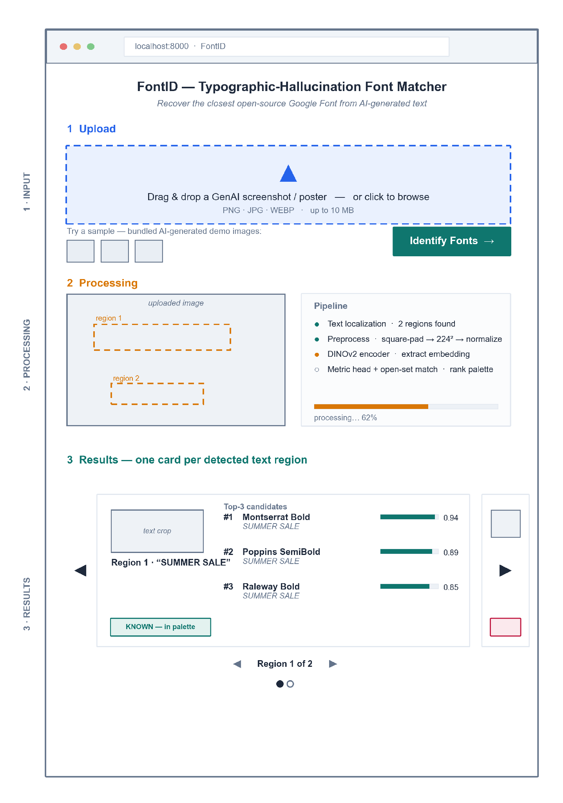
Figure A1 shows a three-zone single page. Results are a carousel, one card per detected region: Region 1 accepts (Top-3 in palette); Region 2, reached with the next arrow, is rejected as out-of-palette (max similarity < τ), demonstrating open-set behavior.

3.2 Hardware Interfaces
No dedicated hardware interface exists. The system runs on a commodity laptop; an NVIDIA GPU, when present, is used through the standard CUDA driver stack, and CPU-only operation is supported. No scanners, sensors, or printers are involved.

3.3 Software Interfaces
Interface | Purpose | Data exchanged
POST /predict (FastAPI REST) | Client sends the image; server returns results. | Request: image (multipart). Response: JSON — per crop, bounding box + Top-K {font, score} + known flag.
HuggingFace Hub | Load DINOv2 + baseline weights at startup. | Model tensors (read-once).
Google Fonts assets | Palette matching + preview rendering of candidate fonts. | Font files (.ttf/.woff2).

3.4 Communications Interfaces
All client–server traffic is HTTP over localhost (REST, JSON, multipart upload). No external network traffic occurs at request time, no email or notification channels exist, and no TLS is required for the single-machine demo.

4. System Features

4.1 Image Input

4.1.1 Description and Priority
User supplies a GenAI image by drag-drop, file browse, or a bundled sample. Priority: High.

4.1.2 Stimulus/Response Sequences
User drops/selects an image → client shows a preview and enables Identify Fonts → click posts the image to /predict.

4.1.3 Functional Requirements
ID | Requirement Description | Priority
REQ-4.1-1 | The system shall accept an image via drag-drop, file picker, or a bundled sample. | High
REQ-4.1-2 | The system shall accept raster images in PNG (.png), JPEG (.jpg, .jpeg), and WebP (.webp) up to 10 MB, and reject any other type (e.g., SVG, GIF, HEIC, TIFF) with a clear message. | High
REQ-4.1-3 | The system shall display a preview of the uploaded image before processing. | Med
REQ-4.1-4 | The app shall bundle a pool of at least 10 real AI-generated sample images (e.g., DALL·E, Midjourney, Stable Diffusion output), none part of any training data; the samples offered shall be randomly selected from this pool at each start-up, and the interface shall label their origin. | Med

4.2 Text Localization and Processing

4.2.1 Description and Priority
The backend finds text regions and prepares each crop for matching. Priority: High.

4.2.2 Stimulus/Response Sequences
/predict receives the image → localizer returns bounding boxes → each crop is preprocessed and embedded → status advances in the Processing zone.

4.2.3 Functional Requirements
ID | Requirement Description | Priority
REQ-4.2-1 | The system shall detect one or more text regions and crop each region for independent matching. | High
REQ-4.2-2 | The system shall preprocess each crop (square-pad → 224² → normalize) inside the model forward pass. | High
REQ-4.2-3 | The system shall show processing status/progress and detected-region boxes while inference runs. | Med
REQ-4.2-4 | The system should return an informative error if no text region is found. | Med

4.3 Font Matching and Top-K Results

4.3.1 Description and Priority
For each crop, the system ranks the palette and decides known vs. unknown. Priority: High.

4.3.2 Stimulus/Response Sequences
Embedding is compared to the palette → if best similarity ≥ τ, return the ranked Top-K; else mark the crop out-of-palette.

4.3.3 Functional Requirements
ID | Requirement Description | Priority
REQ-4.3-1 | The system shall return a Top-K (K = 3) ranked shortlist of Google Fonts per crop, each with a similarity score. | High
REQ-4.3-2 | The system shall reject a crop as “unknown / out-of-palette” when its best similarity falls below threshold τ (open-set). | High
REQ-4.3-3 | The system shall present each crop’s result as its own card in a carousel with previous/next navigation and a region indicator (e.g., “Region 1 of 2”), each card labeled KNOWN or UNKNOWN. | High
REQ-4.3-4 | The system should report a typographic-distance (SSIM) score between the crop and the top match. | Low
REQ-4.3-5 | The backend should log each crop’s similarity scores and its threshold (τ) decision for researcher analysis; these diagnostics are not shown in the user interface. | Low

4.4 Font Preview

4.4.1 Description and Priority
The user visually confirms a match against live-rendered candidates. Priority: Med.

4.4.2 Stimulus/Response Sequences
For each candidate font, the app renders the detected text string in that font beside the crop.

4.4.3 Functional Requirements
ID | Requirement Description | Priority
REQ-4.4-1 | The system shall render each shortlisted font as a live preview of the detected text. | Med
REQ-4.4-2 | The system should let the user copy a candidate font’s name for reuse. | Low

5. Other Nonfunctional Requirements

5.1 Performance Requirements
ID | Requirement Description | Priority
REQ-5.1-1 | The system shall return results for a single-image, ≤5-region upload within ~10 s on the demo laptop (CPU acceptable). | High
REQ-5.1-2 | Model weights shall load once at startup, not per request. | High

5.2 Safety Requirements
The system controls no physical process, so no physical-safety hazards exist. Against data loss: uploaded images are processed in memory and never written to disk, so a crash can lose at most the in-flight request; model weights and font assets are read-only at runtime.
ID | Requirement Description | Priority
REQ-5.2-1 | The system shall open model weights and font assets read-only at runtime, so a failed request cannot corrupt them. | Med

5.3 Security Requirements
As a single-user local demo the app has no authentication and no persistence; no personal data is collected, so no retention obligations arise under data-privacy regulation.
ID | Requirement Description | Priority
REQ-5.3-1 | The system shall process uploads in memory and discard them when the request completes; no upload shall be stored beyond the request lifetime. | High
REQ-5.3-2 | The server shall bind only to the localhost interface and accept no remote connections. | Med

5.4 Software Quality Attributes
ID | Requirement Description | Priority
REQ-5.4-1 | Usability: a first-time user shall complete upload → results without instructions, in one page with no navigation. | High
REQ-5.4-2 | Usability: scores and known/unknown status shall be visible without interaction. | Med
REQ-5.4-3 | Reliability: the system shall handle an unreadable/oversized/textless upload without crashing, returning a clear message. | High
REQ-5.4-4 | Portability: the system shall run from a single Docker image on a clean machine with no manual dependency setup. | Med

5.5 Business Rules
- Only fonts from the open-source Google Fonts palette may be named in a result; the system never identifies or recommends a commercial font.
- A crop whose best similarity falls below τ must be reported as unknown; the system never forces a closed-set label onto an out-of-palette crop.
- Bundled sample images must come from real generative-AI output and must never overlap any training data.

6. Other Requirements
- Licensing: every runtime component and font asset is open-source; the system shall carry no mandatory license or subscription cost.
- Data retention: none — the system stores no user data (see REQ-5.3-1).
- Internationalization: the interface is English-only; the recognition palette is limited to Latin-script fonts, matching the thesis scope.

Appendix A: Glossary
Term | Definition
Typographic hallucination | Probabilistic glyph deformation (warping, kerning jitter, smear) that GenAI introduces into rendered text.
Palette | The curated closed set of 50–100 known Google Fonts the model can name.
Open-set / reject | Returning “unknown” when a crop’s best match falls below threshold τ, instead of forcing a wrong label.
Top-K | The K highest-ranked font candidates for one text crop (K = 3 in the demo).
Embedding | The fixed-length style vector produced by the DINOv2 encoder + metric head.
SSIM | Structural Similarity Index — re-render score between the input crop and the predicted font.

Appendix B: Analysis Models
The analysis models for this system live in Chapter 4 and are not duplicated here: the conceptual framework (Fig 8, §4.4.2) models the offline-training versus at-use data flow, the system-architecture diagram (Fig 9, §4.5.2) models the layered client-server structure, and the iterative-incremental SDLC model (Fig 10, §4.6) models the build sequence.
Traceability. System features 4.1–4.4 realize the §4.5.1 functional requirements (upload · isolate crop · Top-K or unknown · font preview) and are served by the §4.5.2 architecture (Fig 9). Zones in the §3.1 wireframe map one-to-one to features 4.1 (Input), 4.2 (Processing), and 4.3–4.4 (Results).

